27.10.2021г. группа 1ТМ 2 пара
Дисциплина ОДБ.03 Иностранный язык
Преподаватель Романюта Маргарита Вадимовна
Занятие № 14
Модуль 4 «Earth Alert! »
Тема 4.2. The Greаt Barrier Reef.
Цели:
• Образовательная – расширение эрудиции студентов, их общего и лингвистического кругозора на основе практического овладения английским языком;
• Практическая–
1. Развитие навыков чтения, устной речи.
2. Совершенствование коммуникативно-познавательной компетенции студентов по теме «The Greаt Barrier Reef».
• Развивающая – развитие языковых, интеллектуальных и познавательных способностей студентов.
• Воспитательная – воспитание у студентов уважительного отношения к окружающей среде.
1.Работа с лексикой
1.1.Прочитайте слова в словаре WL 13 к занятию
1.2.Запишите в тетрадь слова с транскрипцией.
2.Работа с текстом на стр.75.
2.2. 1а) Look at the pictures . What do you think the Great Barrier Reef is?
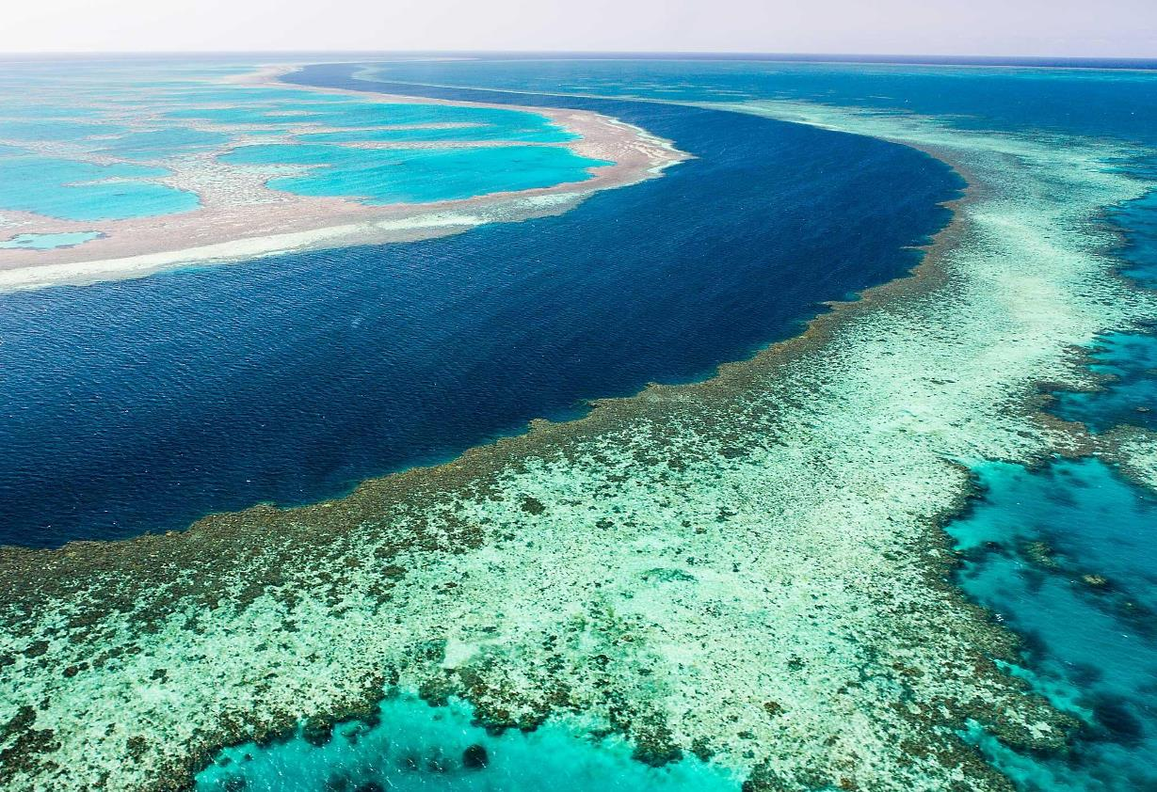
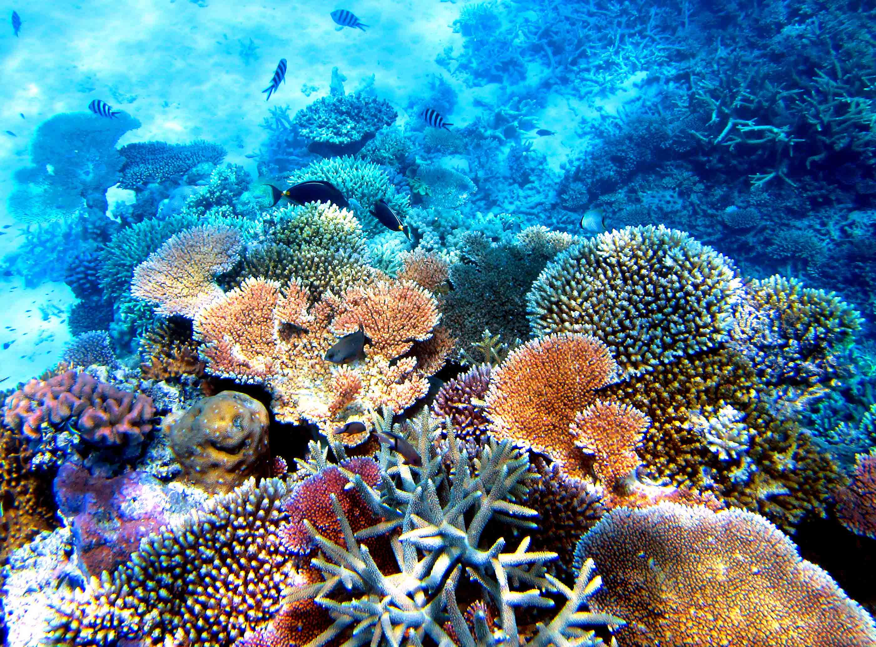
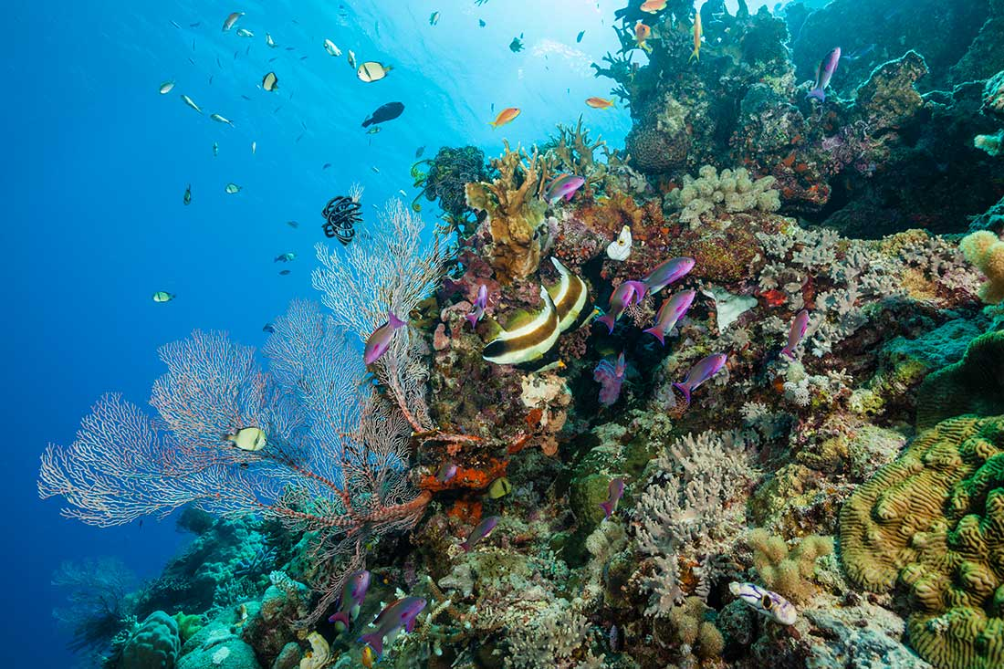
1b) How do you think the phrases below are related to coral reefs?( ex.1b p.75)
2.3.Read the text “The Great Barrier Reef”. Complete the gaps in the text with a word derived from the words in brackets.
The Greаt Barrier Reef
Australia's Natural Treasure
Welcome to Australia's Great Barrier Reef! The 2,000- kilometre long reef is the ….. (large) coral reef system in the world - it is so big that it can be seen from space!
Like many other coral reefs in the world, the Great Barrier Reef is in danger. The numbers of fish and other creatures that live here have fallen …. (drastic) in recent years because of pollution. We need your help to protect this unique ecosystem.
Help us protect the water
The sea around the reefs has been seriously harmed over the years, but you can help reverse this. Don't throw rubbish into the sea as it may contain chemicals that will pollute the water. Rubbish might also float to the surface, which isn't pretty for …..( any) to look at! Help us to keep the water crystal clear so that it can be enjoyed by ….. (every).
Help us protect the coral
Remember that the reef is very much a …..( livе) organism! It has been formed over thousands of years by the …… (act) of tiny creatures called coral polyps. We have to protect these creatures if the reef is to survive. If you are camping on a beach, please be …… (care) what you do with any waste water. Washing-up liquid and bleach can be fatal to coral. If anyone offers to sell you a piece of coral, don't buy it. If you see coral for sale in a shop, tell the authorities …… (immediate).
Help us protect the wildlife
The reef is home to 1,500 species of tropical fish, over 200 types of bird and 20 species of reptile, …… (includе) the endangered Green Sea Turtle. It is also a breeding ground for humpback whales from the Antarctic. Remember - all these creatures depend on the reef for their ….. ( survivе). Please never fish for ….. ( any)! Many species of fish are in danger of ….. (extinct) and therefore protected by law. The same goes for shellfish and other creatures. They may look ….. (beautу), but remember the reef is their home. How would you feel if …… (some) picked you up and took you far away from your home?
Please help us to conserve Australia's natural treasure so that it can be enjoyed for …… (generatе) to come!
3. Упражнение по лексике Модуля 4.
3.1. Fill in: repair, packed, decompose, adoption, compost, rubbish.
1 There are many animals up for ........... at city zoo.
2 We need to ........... the engine so the car runs properly.
3 Have you ……….. your lunch for school today?
4 Do not put things in the...........bin that can be recycled.
5 You can put things that ..........., like vegetable peelings, onto the ……heap.
4.Упражнения на закрепление грамматической темы : «Модальные глаголы»
4.1. What do the modal verbs in bold express?
• prohibition • absence of necessity • obligation • necessity • possibility • asking for permission • negative logical assumption • request• advice
1 You mustn't dump rubbish here. ………
2 He ought to cycle to work more often. ………
3 He can't have failed the exam. ………
4 We should plant more trees in the neighbourhood. ………
5 You needn't come to work in the morning. ………
6 You must fill out this form first. ………
7 We have to reduce waste. ………
8 May I have your name, please? ………
9 I think it might snow soon. ………
10 Could I turn the light off, please? ………
4.2. Fill in: must, mustn't, can, can't, needn't, have to.
1 A: Would you like to come out with us tonight?
B: Oh, I can't. I …. study for my exams.
2 A: You ….. feed the animals in the zoo.
B: I'm really sorry.
3 A: Guess what! I've just won a holiday to Bali.
B: No way! You ….. be joking.
4 A: I'm not feeling well.
B: You ….. see a doctor.
5 A: Look! It's Frank.
B: It ….. be. He said he was staying in tonight.
6 A: This article says people are wasting far too in the home.
B: That's why we ….. all try to save energy...
7 A: You ….. go now if you want to.
B: Thanks. See you tomorrow.
8 A: How about a game of chess?
B: Sorry, but I ….. finish my homework first.
9 A: Would you like me to pick you up later?
B: No, you ….. bother. I'll get the bus.
10 A: Excuse me, sir. You ….. use your mobile phone in here.
B: Oh, I'm sorry.
Домашнее задание:
1.Письменно выполнить упражнение 3.1. и 4.2. данного занятия.
2.Написать эссе на тему: “A protected area in the world”
Срок выполнения задания до 01.11.2021.
Все работы выполнять в рабочих тетрадях, фотографировать и отправлять на адрес преподавателя Романюты М.В. rita.romanyuta@mail.ru
Используемая литература:
1. Афанасьева О.В., Дули Дж., Михеева И.В., Оби Б., Эванс В. УМК «Английский в фокусе» для 10 класса, М.: Просвещение; UK.: Express Publishing: 2018;
2. Агабекян И. П., Коваленко П. И. Английский для технических вузов. Феникс, Ростов-на/Д, 2009.
Дополнительные источники:
- Ионина И., Саакян А. Английская грамматика. Теория и практика. – М.: Академия, 2008.
- Бережная О. О. Сборник новых тем современного английского языка. Донецк, 2009.
Справочники:
- Мюллер В. К. Англо-русский и русско-английский словарь. – М.: ЭКСМО, 2010.
Интернет-ресурсы:
- Портал по изучению английского языка.
Форма доступа: http//www.englishlanguage.ru.
- Сайты для изучения английского языка.
Форма доступа: http://www. study.ru – English Info
http://www.native-english.ru
http://www.study.ru
http://www.homeenglish.ru

